**PROJECT- 4:**

**AIM: Setting up an EC2 Windows Instance with Web Server.**

Steps:

1.initially we need to create an EC2 instance using windows AMI.

* Select the Microsoft Windows Server 2022 Base as the AMI in the free tier category.

2.Provide an existing keypair for the instance.

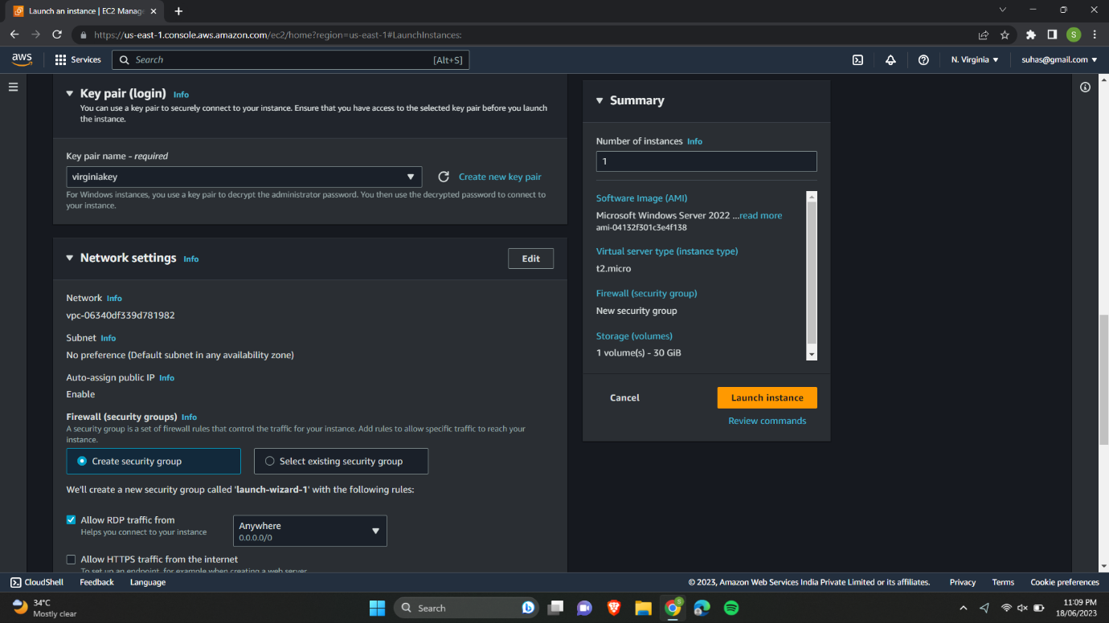

3.In the security group we need to allow RDP traffic in order to connect the instance through remote desktop connection and HTTP to access the web server.

4.In the additional information go to the user data and paste a PowerShell script which represents our webserver.

* PowerShell is a powerful scripting language and command-line shell developed by Microsoft.
* It is primarily used in Windows environments for automating administrative tasks, managing systems, and performing various operations.
* A PowerShell script is a text file containing a series of PowerShell commands and instructions.
* It allows you to automate tasks, execute complex operations, and perform system administration tasks.

5.After launching the instance copy and paste the public Ip in a new tab.

6.we can see our webserver and information in this page is provided in the PowerShell script in the user data.

7.Now we need to connect our EC2 windows instance using RDP client.

8.Click on connect and go to RDP client. Click on get password.

9.In get windows password page we need to upload our key pair file and click on decrypt password.

10.Then we can see our username and password for our windows instance.

11.Go to the remote desktop connection and paste the public Ip of our instance.

* A remote desktop connection allows you to access and control a computer or server from a different location.
* This can be useful for various reasons, such as providing technical support, accessing files or programs on a remote machine, or working remotely.

12.Next with the username and password we can log into our Windows VM.

13.we can see our instance is having windows 10 operating system as default.

